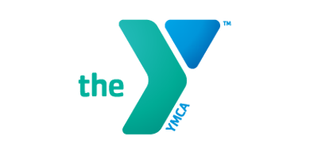
Private and Semi-Private Swim Lessons

Whether you are just starting out or are an experienced swimmer, our instructors will design an individual program plan to help motivate and achieve your swimming goals.
The Price for lessons are as follows:
Private Lessons | Members | Non-Members
30 Minute Private Lesson  45 Minute Private Lesson  60 Minute Private Lesson | $45.00  $65.00  $85.00 | $55.00  $75.00  $95.00
30 Min 10 Pack Lesson  45 Min 10 Pack Lesson  60 Min 10 Pack Lesson | $400.00  $600.00  $800.00 | $500.00  $700.00  $900.00
Semi Private Lessons | Members | Non-Members
30 Minute Private Lesson  45 Minute Private Lesson  60 Minute Private Lesson | $35.00  $60.00  $70.00 | $45.00  $70.00  $90.00
30 Min 10 Pack Lesson  45 Min 10 Pack Lesson  60 Min 10 Pack Lesson | $300.00  $550.00  $650.00 | $400.00  $650.00  $750.00
** Semi Private rate is per child
Please fill out this form and return to the front desk. An Instructor will contact you within 24 hours via E-Mail. If you have any questions or need more information, please contact Jennifer McDonald at jmcdonald@westporty.org or (203) 226-8981 ext. 121. If you need to cancel a lesson, you must provide 24 hour notice to the instructor.
________________________________________________________________________

Name(s): ___________________Age:_______________________
Parents Name: __________________________________________
Phone: _______________________________Email: _____________________________
Instructor Preference (If Known):________________________________
Please list all of your days and times of availability: _______________________________

Private Lesson Attendance Sheet:
Lesson # | Day | Date | Time | Instructor Signature | Parent/Guardian/Participant (If Over 18)
1
2
3
4
5
6
7
8
9
10

