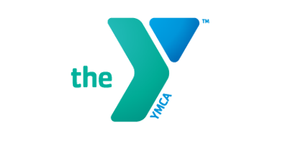
Private Swim Lessons
Whether you are just starting out or are an experienced swimmer, our instructors will design an individual program plan to help motivate and achieve your swimming goals.
The Price for lessons are as follows:
Private Lessons | Members
30 Minute Private Lesson | $50.00
30 Min 5 Pack Lesson | $225.00

Please fill out this form and return to the front desk. An Instructor will contact you within 24 hours via E-Mail. If you have any questions or need more information, please contact Jennifer McDonald at jmcdonald@westporty.org

If you need to cancel a lesson, you must provide 24 hour notice to the instructor.

________________________________________________________________________

Name(s): ___________________Age:_______________________
Parents Name: __________________________________________
Phone: _______________________________Email: _____________________________
Instructor Preference (If Known):________________________________
Please list all of your days and times of availability: _______________________________

